Riverton Street Charter School Project #2
Social Studies Grade 6 (UCHi & UCLA) February 17, 2022

The Eastern Hemisphere Project:
You are required to prepare a Fact Sheet based on research on a country of Africa that you would like to visit in the future. You must choose a country from the region given and explore the different geographic and historical features that make that country special.
Include
-Name, map, location and flag of the country
-Climate, major cities, important geographic features
-Population, President / Prime Minister (leader)
-Any important place and interesting fact(s).
-Briefly explain what attracted you to visit that country.

Your Fact Sheet must
-Be typed–written in a reasonable size font
-References: list your source
(where you got your information – books, magazines, the Internet)
-Include your name, class, and date.
-Have an appealing / interesting title.

Be Creative! Use pictures and color.

Due date: Wednesday, March 2, 2022

Map of Africa – Political

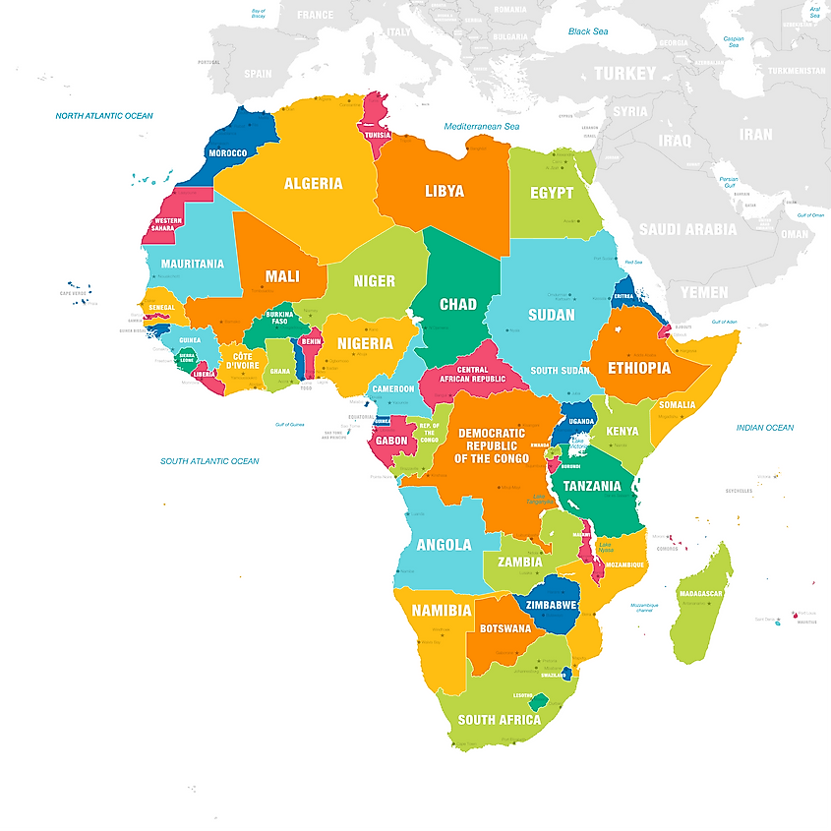

Sample to guide your research & presentation
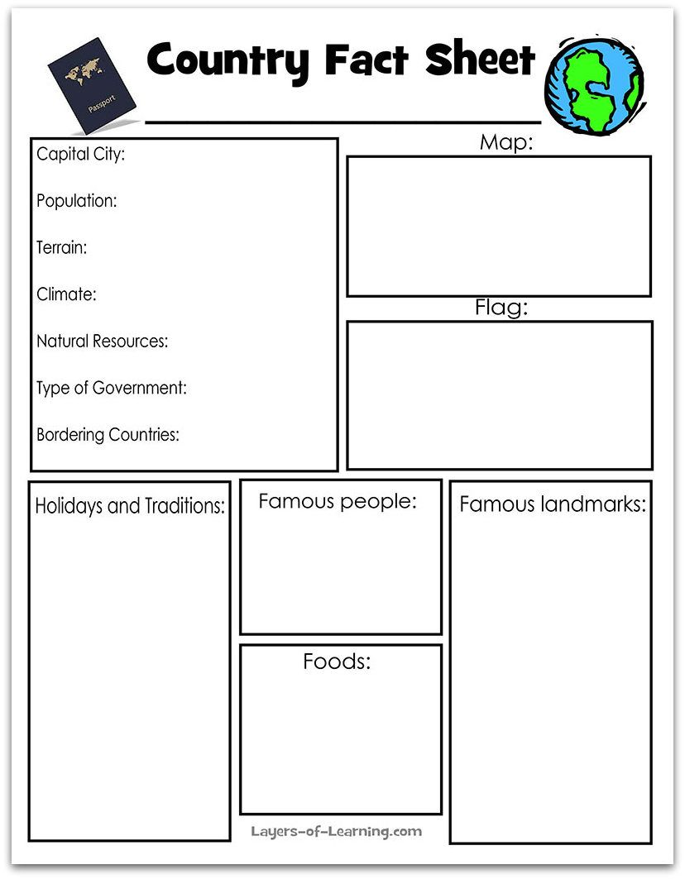

Geography of the Eastern Hemisphere – Fact Sheet
 | 4 | 3 | 2 | 1
Organization | The fact sheet has excellent formatting and organization of information.  All source of information is cited properly. | The fact sheet has appropriate formatting and well-organized information.  Some source of information is cited properly. | The fact sheet has some organized information with  random formatting.  Source of information is cited is limited. | The fact sheet format and organization of materials are confusing to the reader.  Source of information is not cited.
Ideas | The fact sheet communicates relevant information appropriately and effectively to the intended audience. | The fact sheet communicates relevant information appropriately to the intended audience. | The fact sheet communicates irrelevant information or communicates inappropriately to the intended audience. | The fact sheet communicates irrelevant information and communicates inappropriately to the intended audience.
Conventions | All of the writing is done in complete sentences.  Capitalization and punctuation are accurate throughout the fact sheet | Most of the writing is done in complete sentences.  Most of the capitalization and punctuation are accurate throughout the fact sheet. | Some of the writing is done in complete sentences.  Some of the capitalization and punctuation are accurate throughout the fact sheet. | Most of the writing is not done in complete sentences.  Most of the capitalization and punctuation are not accurate throughout the fact sheet.
Graphics | The graphics go well with the text, and there is a good mix of text and graphics | The graphics go well with the text, but there are too many, that they distract the reader. | The graphics go well with the text, but they are too few. | The graphics do not go well with the accompanying text, and they appear to be randomly selected.

